**Smart Energy Saving System with Automated Room Monitoring**

**Project Report**

**1. Introduction**

Energy conservation is crucial in modern-day buildings. This project introduces a smart energy-saving system that automates room monitoring using IR sensors. It efficiently controls lights and fans based on the number of people present, reducing unnecessary energy consumption.

**2. Objectives**

* To develop an automated system for monitoring room occupancy.
* To control lights and fans based on the presence of individuals.
* To optimize energy consumption in homes, offices, and public spaces.

**3. Components Required**

* **Arduino Uno** – Microcontroller board to process sensor data.
* **IR Sensors (2x)** – Detect entry and exit of individuals.
* **7-Segment Display/LCD** – Displays the count of people inside.
* **Relay Module** – Controls the operation of lights and fan.
* **LED** – Represents the state of the lights.
* **DC Motor (Optional)** – Represents a fan for demonstration.
* **Resistors & Wires** – Electrical components for circuit connections.

**4. Working Principle**

1. Two IR sensors are placed at the entrance.
2. If **Sensor 1** detects movement before **Sensor 2**, a person is entering, and the counter increases.
3. If **Sensor 2** detects movement before **Sensor 1**, a person is exiting, and the counter decreases.
4. If the count is **1 or more**, the lights and fan turn **ON**.
5. If the count is **0**, the lights and fan turn **OFF**.

**5. Circuit Diagram & Explanation**

* **IR Sensors**: Detect movement at the door and send signals to Arduino.
* **Arduino Uno**: Processes input from sensors and controls the relay module.
* **Relay Module**: Turns the electrical appliances ON/OFF based on the counter.
* **Display (LCD/7-Segment)**: Shows the number of people inside.
* **LED/DC Motor**: Indicates the state of the system.

**6. Arduino Code**

int sensor1 = 2; // First IR sensor (Entry)

int sensor2 = 3; // Second IR sensor (Exit)

int relay = 4; // Relay for light and fan

int count = 0; // Person count

void setup() {

pinMode(sensor1, INPUT);

pinMode(sensor2, INPUT);

pinMode(relay, OUTPUT);

Serial.begin(9600);

}

void loop() {

if (digitalRead(sensor1) == HIGH) { // Detect Entry

delay(100); // Debounce

if (digitalRead(sensor2) == HIGH) { // Confirm movement

count++;

Serial.print("People in room: ");

Serial.println(count);

delay(500);

}

}

if (digitalRead(sensor2) == HIGH) { // Detect Exit

delay(100);

if (digitalRead(sensor1) == HIGH) {

if (count > 0) count--; // Avoid negative values

Serial.print("People in room: ");

Serial.println(count);

delay(500);

}

}

// Turn ON/OFF Light & Fan

if (count > 0) {

digitalWrite(relay, HIGH);

} else {

digitalWrite(relay, LOW);

}

}

CIRCIUT DIAGRAM(Tkider cad)

With push button as input for arduino

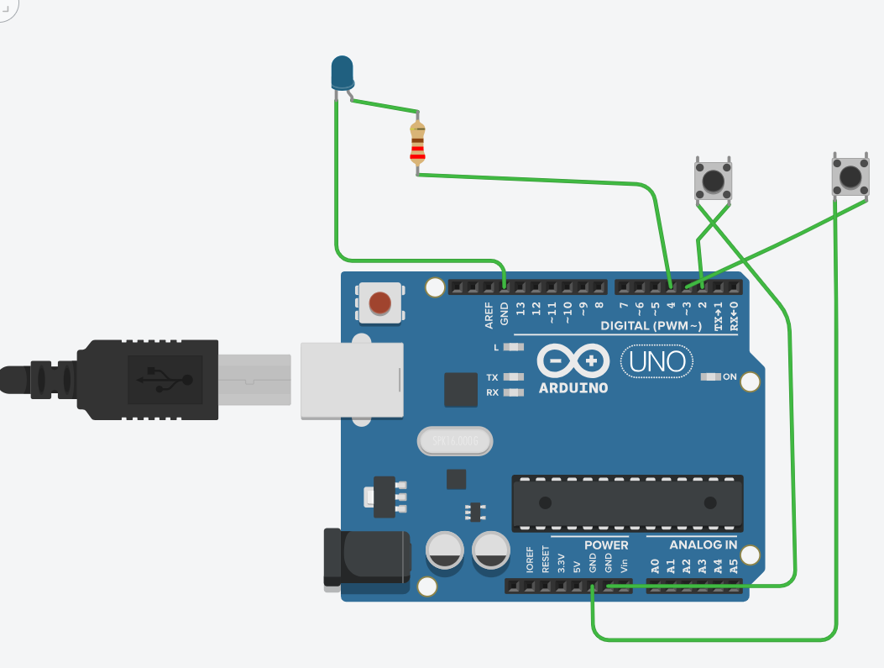

With ir sensors as input for arduino

**7. Applications**

* **Smart Homes**: Automates lighting and fan control.
* **Offices & Commercial Buildings**: Reduces electricity wastage.
* **Educational Institutions**: Ensures energy efficiency in classrooms.
* **Public Spaces**: Automatically manages lights and appliances.

**8. Advantages**

* **Energy Efficiency**: Reduces power consumption.
* **Automation**: No manual intervention required.
* **Cost-Effective**: Saves electricity bills.
* **Eco-Friendly**: Supports sustainable energy use.

**9. Conclusion**

This smart energy-saving system efficiently manages room appliances by monitoring occupancy in real-time. It is a practical, cost-effective, and eco-friendly solution for smart homes, offices, and public buildings, contributing to a sustainable future.